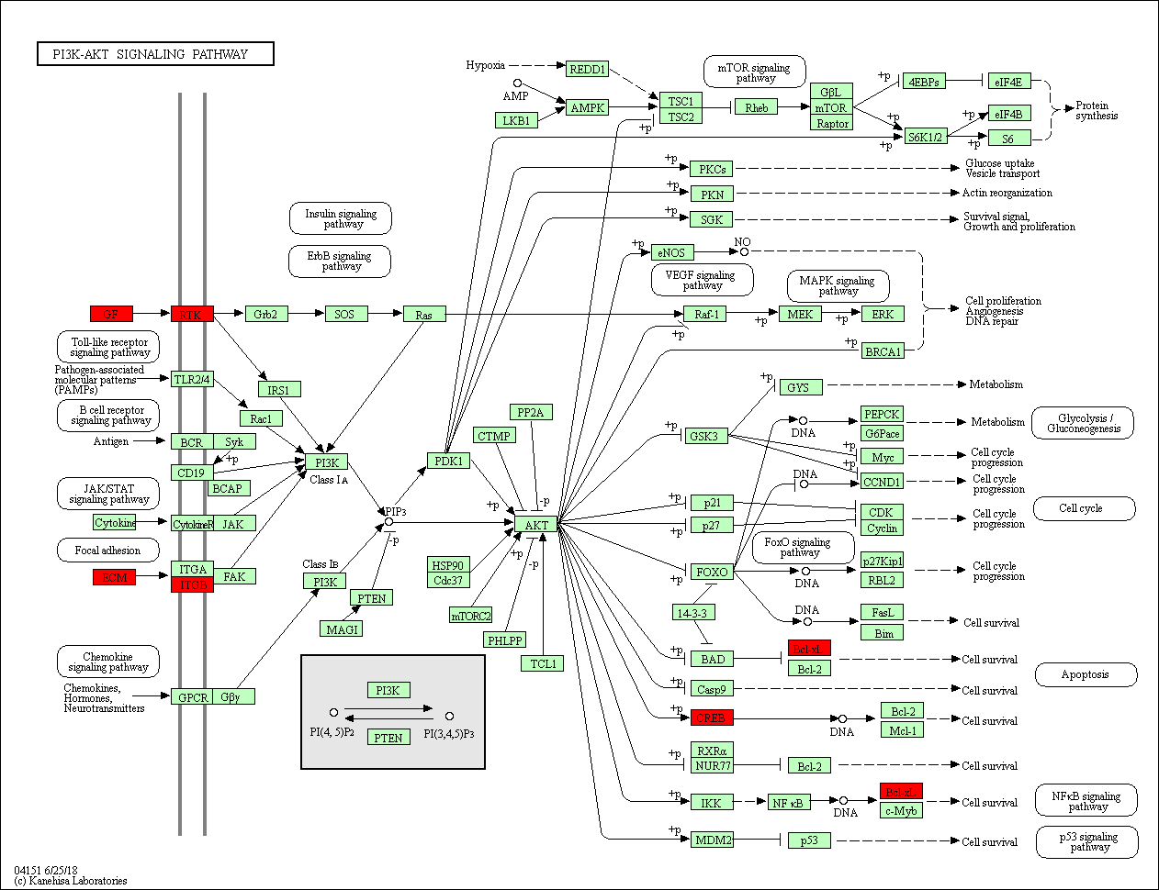
Figure S1. PI3K-Akt signaling pathway network generated by KEGG analysis. FGF9, VEGFA, PDGFRA, CREB3L1, BCL2L1 and LAMC1 were predicted as target genes of rno-miR-140-5p and enriched in the PI3K-Akt pathway (located in the red region).

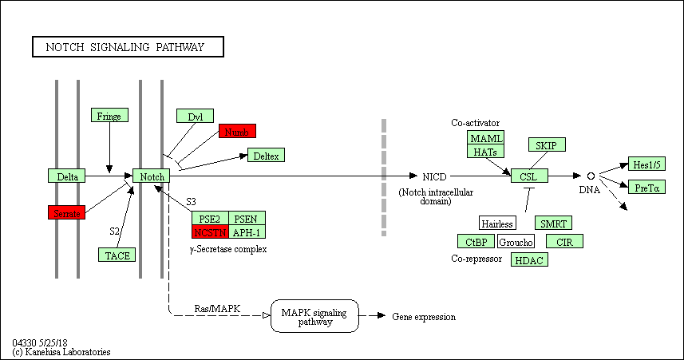
Figure S2. Notch signaling pathway network generated by KEGG analysis. NCSTN, JAG1 and NUMBL were predicted as target genes of rno-miR-140-5p and enriched in the Notch pathway (located in the red region).

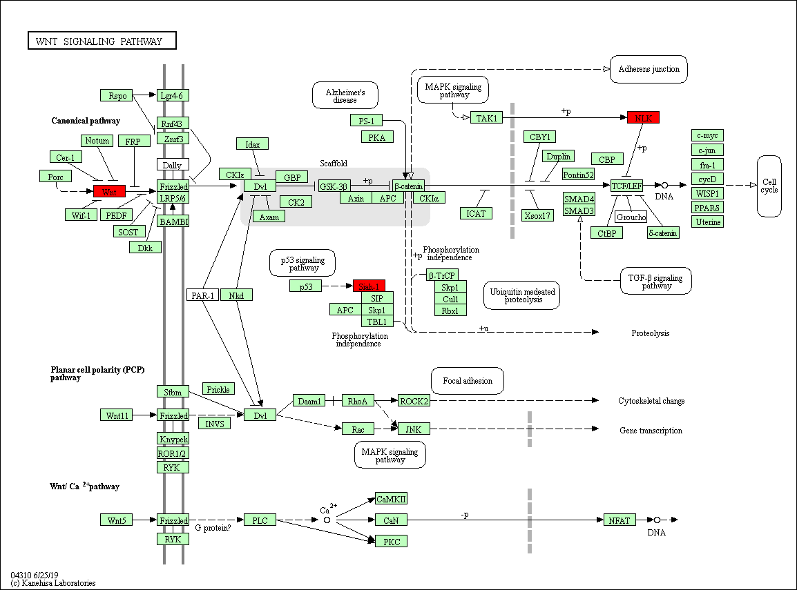
Figure S3. Wnt signaling pathway network generated by KEGG analysis. WNT1, NLK, SIAH1 and WNT9A were predicted as target genes of rno-miR-140-5p and enriched in the Wnt pathway (located in the red region).

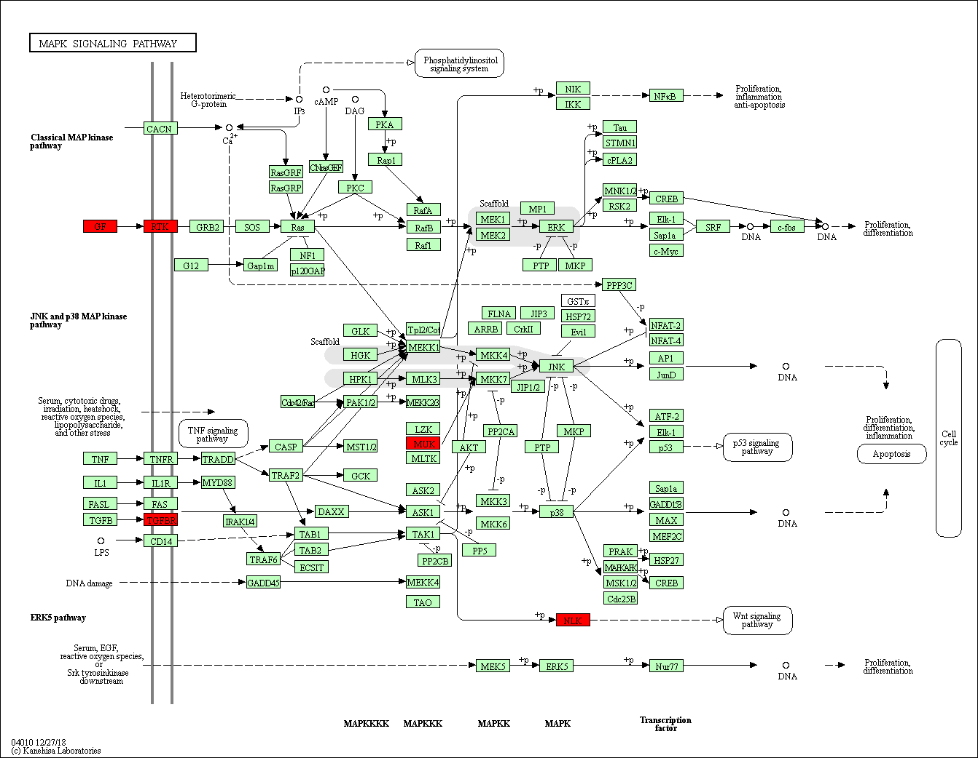
Figure S4. MAPK signaling pathway network generated by KEGG analysis. FGF9, TGFBR1, NLK, PDGFRA and MAP3K12 were predicted as target genes of rno-miR-140-5p and enriched in the MAPK pathway (located in the red region).

